C400R USER MANUAL  A COMPLETE INSTALLATION AND USER GUIDE | THE C400R SERIES  An uninterruptible power supply (UPS) incorporating online double conversion technology, which eliminates all mains power disturbances.  www.certaups.com  For assistance please contact your local CertaUPS partner.

Contents

SAFETY INFORMATION 6
USER MANUAL SYMBOLS 6
HANDLING 6
OPERATING SAFETY 7
THE MODEL LIST 8
THE TECHNOLOGY 8
SUITABLE APPLICATIONS 9
UPS STANDARDS 9
UPS INSTALLATION 10
UNPACKING 10
C400R BOX CONTENTS CHECKLIST 10
INSTALLATION 11
C400R TOWER MODEL INSTALLATION 11
C400R RACKMOUNT MODEL INSTALLATION 13
WIRING 15
C400R SERIES STARTUP AND SHUTDOWN 15
STARTING THE UPS WITH MAIN POWER PRESENT 15
STARTING THE UPS FROM BATTERY 15
UPS SHUTDOWN WITH MAINS POWER 16
UPS SHUTDOWN WITHOUT MAINS POWER 16
C400R SERIES OPERATION 17
LCD DESCRIPTION 17
DISPLAY FUNCTIONS 18
USER SETTINGS 19
LCD MENU SYSTEM 20
MAIN MENU 20
UPS STATUS 20
MEASUREMENTS MENU 21
EVENT LOG 22
CONTROL MENU 22
IDENTIFICATION MENU 22
SETTINGS MENU 4
COMMUNICATION PORTS 5
EPO CONNECTION 5
DRY IN/DRY OUT CONTACTS 5
INTERFACE CARDS (OPTIONAL) 6
SOFTWARE 6
UPS MAINTENACE 7
UPS CARE 7
TRANSPORTING THE UPS 7
STORING THE UPS 7
BATTERY REPLACEMENT 8
REPLACING THE EBM 8
RECYCLING A UPS 9
TECHNICAL DATA 12
ELECTRICAL SPECIFICATION 13
OPERATING ENVIROMENT 13
RUNTIMES 14
DIMENSIONS AND WEIGHTS 14

SAFETY INFORMATION
KEEP THESE INSTRUCTIONS IN A SAFE PLACE
This section contains essential information and instructions that should be followed to ensure the safe handling, installation and maintenance of CertaUPS equipment and batteries.

USER MANUAL SYMBOLS

The following will be referenced throughout this document.

SYMBOL | DEFINITION
 | Caution! Follow instructions carefully
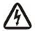 | Caution, risk of electric shock
 | Power On/Off
 | Alternating current (AC)
 | Direct Current (DC)
 | Grounding
 | Recycle
Not to be disposed of in general waste
Waste electrical equipment or electronic equipment (WEEE) should not be disposed of in the general waste. CertaUPS systems should always be disposed of at a proper recycling/hazardous waste disposal centre. Please see page 10 for disposal guidance.

HANDLING

UPS handling weight guidelines

<18kg (<40lb) | One-person
18 – 32 kg (40 – 70 lb) | Two-person
32 – 55 kg (70 – 120 lb) | Three-person
>55 kg (>120 lb) | Forklift
AUTHORISED PERSONNEL TO HANDLE ONLY
UPS systems contain both AC and DC when disconnected from the mains outlet and should only be serviced by qualified persons.

Before any handling please ensure that the following precautions are taken:

QUALIFIED PERSONNEL Any persons servicing the UPS must be qualified and knowledgeable in UPS technology and batteries
CLOTHING Correct PPE should always be worn
POWER OFF Ensure all mains power is disconnected before starting work
TOOLS always use insulated tools. Do not lay tools down near the Ups or batteries. Follow all insolation procedures.
UPS GROUNDING The UPS must always be properly grounded

CAUTIONARY NOTES

Please be aware of the following risks when handling and operating CertaUPS units.

RISK TYPE | DETAILS
Electric shock | Even after the unit is disconnected from the mains power supply (building outlet socket), components inside the UPS are still energised from the battery which are potentially dangerous.
 | The battery circuit is not isolated from the input voltage. Hazardous voltages may occur between the battery terminals and the ground. Verify that no voltage is present before servicing.
Hazardous voltages | Repairs must be carried out only by qualified UPS Engineer.
FOR FURTHER INFORMATION ON REPLACEMENT PARTS AND SERVICING PLEASE CONTACT YOUR CertaUPS PARTNER.

OPERATING SAFETY

Before operating any UPS system, please read the following guidance:

DO NOT install the UPS in a humid environment or expose to liquids
DO NOT block the ventilation of the UPS
DO NOT expose the UPS to direct sunlight or source of heat
DO NOT exceed ambient temperatures when operating or storing the UPS
DO NOT allow excessive particulates or foreign bodies to enter the UPS

DO follow all connection procedures and operational instructions in the order in which they appear within this manual
DO check that the indicators on the rating plate correspond to the AC powered system and to the actual electrical consumption of all the equipment to be connected to the UPS
DO ensure the outlet is installed near the UPS and is easily accessible
DO store the UPS in a dry environment
DO keep the UPS in a well-ventilated area

Additional considerations:

- To reduce the risk of fire or injury the unit must be supplied by a circuit which is protected by overcurrent by means of an MCB or other protective devices.

- The upstream circuit breaker or local means of isolation must be easily accessible. The unit can then be disconnected from the AC power source by opening the circuit breaker/isolator.

- If An additional AC contactor is to be used for back feed protection, this must comply with IEC/EN 62040-1

- Disconnection and overcurrent protection devices shall be provided by others for permanently connected AC input (Normal AC/Bypass AC) and AC output circuits.

- The admissible storage temperature range is -15ºC to +40ºC with battery, -25ºC to +60ºC without battery.

- The operating temperature should be kept between 20 ºC to 25 ºC, failure to do so will reduce the expected battery design life

PRODUCT OVERVIEW
FULL PRODUCT DETAILS CAN BE FOUND AT WWW.CERTAUPS.COM/PRODUCT/CERTAUPS-C400R/

The CertaUPS C400R series is an uninterruptible power supply (UPS) incorporating online double conversion technology, which eliminates all mains power disturbances.

THE MODEL LIST

Please check that the unit you have purchased is correct by referring to the model number, which appears on the rear panel of the UPS unit.

ITEM | MODEL NAME | POWER RATING | MODEL TYPE | MODEL DESCRIPTION | OTHER
1 | C400R-010-B | 1000VA/900W | Rack | Internal battery model | Single Phase input  Single Phase output
2 | C400R-010-C | 1000VA/900W | Rack | Charger model | Single Phase input  Single Phase output
3 | C400R-020-B | 2000VA/1800W | Rack | Internal battery model | Single Phase input  Single Phase output
4 | C400R-020-C | 2000VA/1800W | Rack | Charger model | Single Phase input  Single Phase output
5 | C400R-030-B | 3000VA/2700W | Rack | Internal battery model | Single Phase input  Single Phase output
6 | C400R-030-C | 3000VA/2700W | Rack | Charger model | Single Phase input  Single Phase output

THE TECHNOLOGY

The C400R UPS series uses online double conversion technology, which ensures that clean and stable power is always provided. An online UPS operating in, line mode always provides a consistent supply of AC power to the load. This is done by using the battery and the inverter to ensure a clean stable and supply. When the mains power fails, the battery is no longer supplied by the rectifier and the batteries begin to discharge.

Once the battery is depleted the UPS will no longer be able to generate AC power through the inverter and the output will in turn cease. Once the mains power is restored the rectifier will charge the batteries and then allow the inverter to provide power to the load once more.

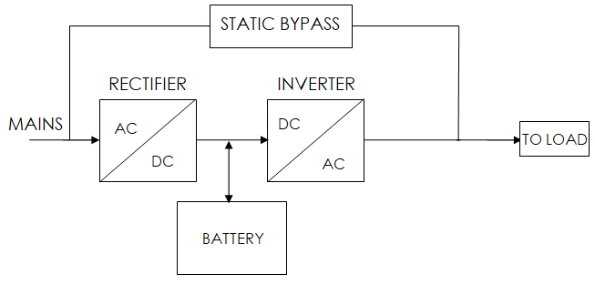

Key features:

- Wide input voltage window
- 0.9 power factor
- Frequency converter feature
- EPO connection
- Future expansion or redundancy
- Internal manual bypass
- Small footprint

SUITABLE APPLICATIONS

Ideally suited for small to medium-sized offices, telecoms centres and security facilities. Please see list below (not exhaustive):

Small data centres
Server room
IT facilities
Telecoms
Networking

ACCESSORIES

PART | DESCRIPTION
C-NMC | SNMP Network management card
C-REL | Relay card
C-DB9REL | Relay card (DB9 Interface)
C-EMP | Environmental monitoring probe (SNMP required)
C-MOD1 | Modbus interface
MBSRACK 1-3 | Rack-mountable Maintenance bypass switch

UPS STANDARDS

DESCRIPTION | STANDARD
Conduction/Radiation | IEC/EN 62040-2
Harmonic Current | IEC/EN 61000-3-2
Voltage Fluctuation | IEC/EN 61000-3-3
ESD | IEC/EN 61000-4-2
RS | IEC/EN 61000-4-3
EFT | IEC/EN 61000-4-4
Surge | IEC/EN 61000-4-5
CS | IEC/EN 61000-4-6
MS | IEC/EN 61000-4-8
Voltage Dips | IEC/EN 61000-4-11
Low frequency signals | IEC/EN 61000-2-2
PLEASE FIND UPS PRODUCT DIAGRAMS AND FULL TECHNICAL SPECIFICATIONS ON PAGE 32 OR VISIT WWW.CERTAUPS.COM/PRODUCT/CERTAUPS-C400R/

UPS INSTALLATION
PLEASE ENSURE ALL SAFETY INSTRUCTIONS HAVE BEEN OBSERVED AND UNDERSTOOD PRIOR TO UNPACKING AND INSTALLING THE UPS

INSPECTION

Every effort is made to ensure that CertaUPS systems are packaged as safely as possible to ensure that no damage is incurred during shipment. Please visually inspect the UPS when it is received. Please keep all packaging in a safe place for future use.
IF THE DEVICE IS DAMAGED, PLEASE NOTIFY THE CARRIER IMMEDIATELY

UNPACKING

The UPS unit must be positioned in a well-ventilated area that is free from excessive dust, heat and moisture. Please take note of the specified operating temperatures and remain within these guidelines.

- Unpacking the unit in a low-temperature environment may cause condensation to occur in and on the device. DO NOT install the UPS/EBM until the inside and outside of the device are clear of condensation.

- The UPS/EBM is heavy. Follow any special precautions provided on the carton.

- Unpack the equipment and remove shipping carton and all the packaging materials. DO NOT lift the using the front panel and rear panel.

PACKING MATERIALS MUST BE DISPOSED OF IN COMPLIANCE WITH ALL LOCAL WASTE MANAGEMENT REGULATIONS.

RECYCLING SYMBOLS ARE PRINTED ON THE PACKING MATERIALS TO FACILITATE SORTING.

Rackmount/Tower model
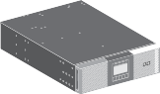
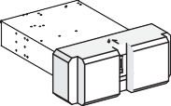

C400R BOX CONTENTS CHECKLIST

C400RR Series UPS
Rack rails
USB A to B
Software CD
Quick Start Guide
Warranty Card
Horizontal stabilising bracket
IF ANY OF THE ITEMS ARE MISSING FROM THE UPS BOX PLEASE NOTIFY YOUR SUPPLIER

DO NOT FORGET TO REGISTER THE UPS WARRANTY WWW.CERTAUPS.COM/SUPPORT/WARRANTY-REGISTRATION/

INSTALLATION
DO NOT MAKE ANY UNLICENSED MODIFICATIONS TO THE UPS. THIS MAY INCUR DAMAGE AND AFFECT THE UPS WARRANTY.

- DO NOT connect the UPS to a mains supply until installation is completed
- Ventilation of the UPS is important for proper operation. Ensure the air vents on the front, side and rear of the UPS are clear. Allow adequate space around the UPS. The airflow diagram is shown as below:

Installation considerations:

- The final location of the UPS unit must be on a flat stable surface in a well-ventilated environment
- DO keep at least 150mm of free space behind the rear panel
- If installing an additional unit, place it next to the first unit in its final location
- DO allow the UPS to reach ambient temperature before turning on
- The UPS needs to be fully charged to achieve full autonomy

C400R TOWER MODEL INSTALLATION
A QUICK START VIDEO GUIDE FOR THE C400R TOWER MODEL IS AVAILABLE AT WWW.CERTAUPS.COM/MEDIA

Tools required:

- Insulated screwdriver
- Box Contents

STEP ONE | Ensure utility power is switched off.
STEP TWO | Carefully place the UPS within the stands.
STEP THREE | Pull out the LCD panel and carefully rotate it taking care not to damage the cable.  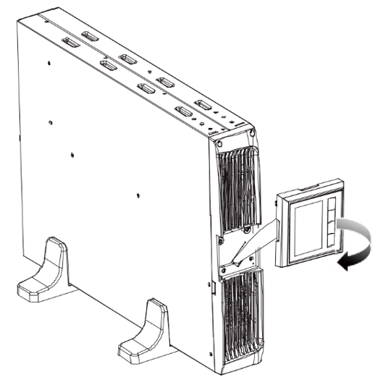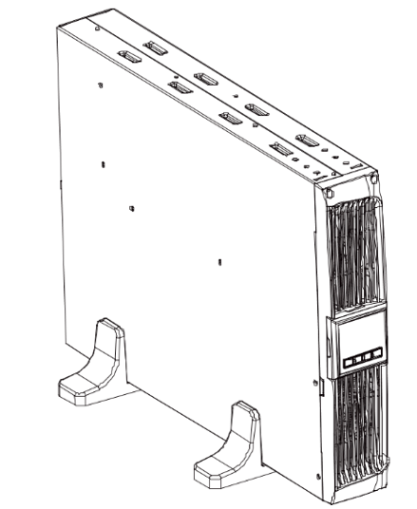
STEP FOUR | If not installing additional EBMs skip to step six  Position the UPS and External Battery Modules (EBM) within the extended UPS stands then slide the stands to either end of the tower finally, on top of the units screw in the joining plate provided for extra stability.  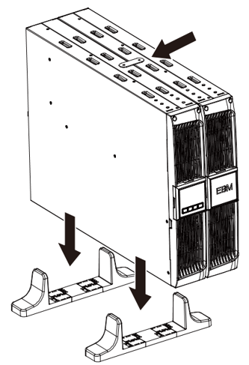  Connect an Earth line from the UPS (port A) to the EBM (port B)  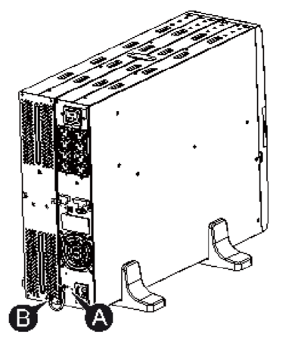  Take off the front panel. To do this remove the 2 top screws from the front of the UPS and carefully take out the LCD screen and remove the screw that is behind it. Finally, push inward the small blanking plate on the side of the front panel in order to remove it. This then enables you to connect the battery terminal (A) from the UPS to the EBM terminal (B) shown below. After doing this reassemble the front panel  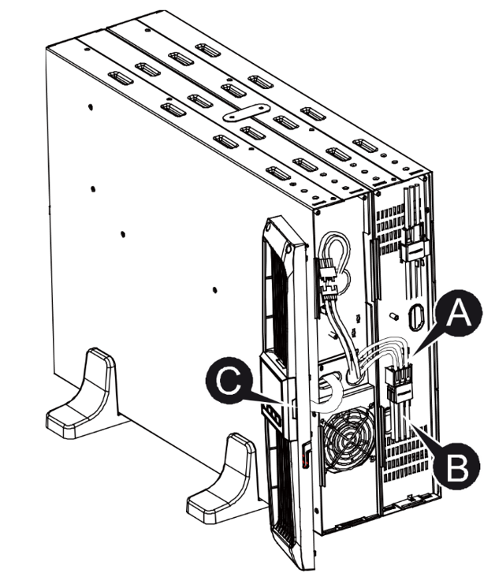  After setting up the UPS the load can then be connected. Please make sure the load equipment is turned off before connecting all loads into the output C13/C19 ports
STEP FIVE | If not connecting multiple EBMs skip to step six.  To connect multiple EBMs in tower form for use the same method as assembling the UPS/EBMs in rack form.  To install multiple EBMs connect an Earth line between the UPS and the first EBM and then connect a second Earth line between the first EBM and the second EBM  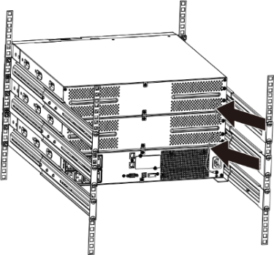  Take off the front panel as instructed in the previous steps, This then enables you to connect the battery terminal (A) from the UPS to the EBM terminal (B) shown below. Then connect the battery terminal (D) from the first EBM to the battery terminal (E) of the second EBM. The user then needs to reassemble the front panel  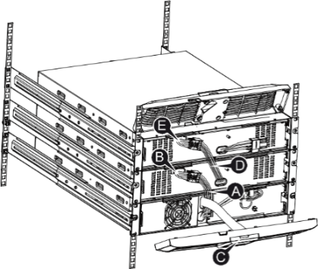
STEP SIX | Plug the UPS into a mains power socket and turn Utility power ‘ON’. The UPS will power on in bypass mode and begin charging
STEP SEVEN | Switch the UPS from bypass mode to online. Press and hold button for longer than 3 seconds. After a short while, the LCD display will show signalling that the UPS is powered and protecting the equipment

C400R RACKMOUNT MODEL INSTALLATION
A QUICK START VIDEO GUIDE FOR THE C400RR RACKMOUNT/TOWER MODEL IS AVAILABLE AT WWW.CERTAUPS.COM/MEDIA

This series of UPS can be placed horizontally and vertically, with the LCD screen rotating 90 degrees.

STEP ONE | Ensure the master input breaker switch is OFF
STEP TWO | Installing the UPS in a rack position:  Install the L bracket(s) to the unit  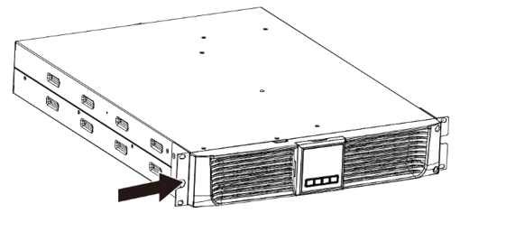  Install the unit to the rack cabinet in a suitable U-space (Pre-install rail kit)  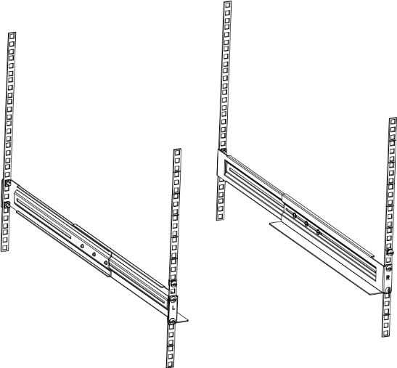  Slide the UPS into the rack rails and lock it into the rack enclosure  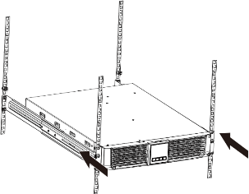  Tighten the screws. The UPS is now ready for cabling unless you are installing EBMs.
STEP FOUR | If not installing additional EMBs skip straight to step six.  Using the same method as assembling the UPS in rack form.  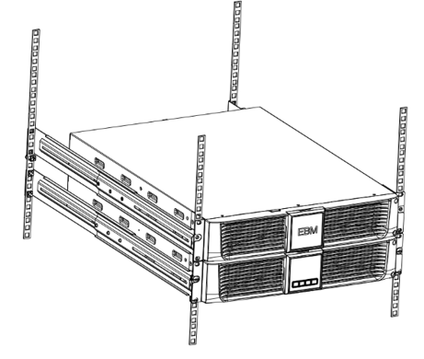  Connect the earth line between mounting point A & B  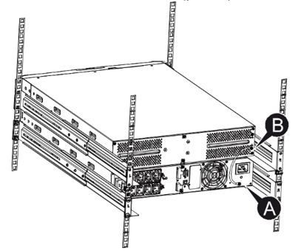  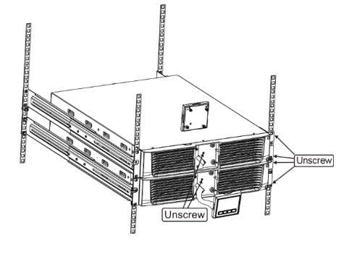  Take off the front panel. To do this remove the 2 screws from the right-hand side of the front of the UPS, carefully take out the LCD screen and remove the screw behind it.  Finally, push inward the small blanking plate on the side of the front panel in order to remove it. This then enables you to connect the battery terminal (A) from the UPS to the EBM terminal (B) shown below. After doing this reassemble the front panel.  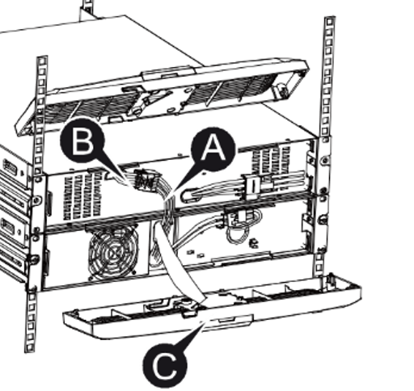
STEP FIVE | If 1 or fewer EBMs are to be connected skip to step six  To install multiple EBMs connect an Earth line between the UPS and the first EBM and then connect a second Earth line between the first EBM and the second EBM  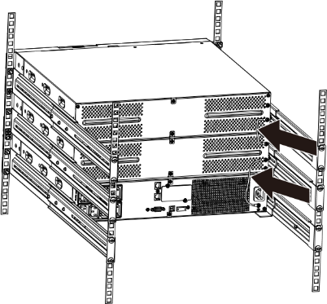  Take off the front panel as instructed in the previous steps, This then enables you to connect the battery terminal (A) from the UPS to the EBM terminal (B) shown below. Then connect the battery terminal (D) from the first EBM to the battery terminal (E) of the second EBM. The user then needs to reassemble the front panel  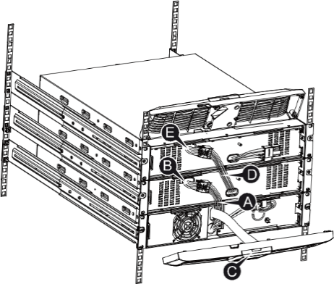
STEP SIX | Plug the UPS into a mains power socket and turn the power on. The UPS will power on in bypass mode and begin charging
STEP SEVEN | To switch the UPS from bypass mode to online. Press and hold for button for longer than 3 seconds. After a short while, the LCD display will show signalling that the UPS is powered and protecting the equipment.

Read the UPS safety instructions back-feed protection requirements page 7

C400R SERIES STARTUP AND SHUTDOWN

STARTING THE UPS WITH MAIN POWER PRESENT

Please switch off the connected loads before turning on the UPS, and switch on connected devices one by one after the UPS is turned on. Switch off all connected loads before turning off the UPS.

The C400R Series UPS can be started either “hot” or “Cold”, this means the UPS can be activated regardless of whether the unit has a main supply (Hot) or if no mains power is available (Cold).

Verify that the total equipment ratings do not exceed the UPS capacity to prevent an overload alarm.

To start the UPS via mains power (Hot start):

- Check all the connections are properly connected and correct.

- Supply mains power to the UPS, the fans will start and the LCD will show the default UPS status summary screen and be in static bypass mode.

- Hold the button continuously for more than 3 seconds and UPS shall start to turn on.

- After a few seconds, the UPS will start in Line mode. If the utility power is abnormal, the UPS will transfer to battery mode without output interruption to the UPS.

- When the UPS is online the 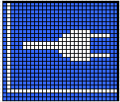 icon will be displayed

STARTING THE UPS FROM BATTERY

Before using this feature, the UPS must have been powered by utility power with output enabled at least once to ensure the unit is adequately charged.

After connecting the UPS to any EBMs you should wait for at least 10s before pressing the button for pre-charging of the auxiliary power supply.

Battery start can be disabled.

To start the UPS via battery power (Cold start):

- Check all the connections are properly connected and correct.

- Press the button continuously for more than 100ms, the UPS will power on. The fans will start and the LCD will show the default UPS status summary screen after finishing the initialisation self-test.

- Pressing the button continuously for more than 1 second and the UPS will start to turn on and initialise.

- After a few seconds, the UPS will transfer to battery mode. If the mains power comes back the UPS will transfer to Line mode without output interruption of the UPS.

- When the UPS is running from battery power the 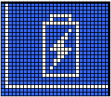 icon will be displayed, when mains power is restored the icon will change to .

UPS SHUTDOWN WITH MAINS POWER

When in Bypass UPS output voltage is still present!

To shutdown the UPS with mains power:

- Press the button continuously for more than 3 seconds.

- After that, the UPS will transfer to bypass mode immediately.

- In order to cut off the UPS output remove the mains power supply. A few seconds later the LCD display will shut down and no output power is available from the UPS output terminal.

UPS SHUTDOWN WITHOUT MAINS POWER

To shutdown the UPS without mains power:

- Power off the UPS by pressing the button continuously for more than 3 seconds and the UPS output will stop.

- A few seconds later the LCD display will power off.

C400R SERIES OPERATION

FRONT PANNEL

The CertaUPS C400R has a four-button user interface and graphical LCD. It provides useful information about the UPS itself, load status, events, measurements and settings. In the event of a critical alarm, the LCD backlight will illuminate red.

The following table shows the indicator status and description:

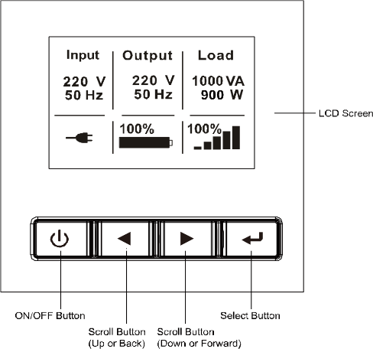
BUTTON | FUNCTION | DESCRIPTION
 | Power on | When the unit has no mains power and batteries connected, press for >100ms & <1s to power on
 | Turn on | When the unit is powered on and in Bypass mode, press this button for >3s to turn on
 | Turn off | When the unit has been turned on, press this button for >3s to turn off
 | Enters the main menu | When displaying the default UPS status summary screen, press this button for >1s to enter the main menu tree
 | Exit main menu | Press this button for >1s to exit the present menu to default system status display menu without executing a command or changing a setting
 | Scroll up | Press this button <1s to scroll up the menu option
 | Scroll down | Press this button for <1s to scroll down the menu option
 | Enter next menu tree | Press this button for <1s to select the present menu option, or enter next menu, but not change any settings
 | Select one menu option | Press this button for <1s to select the present menu option, or enter next menu, but not change any settings
 | Confirm the present setting | Press this button for >1s to confirm the edited options and change the setting

IF AN ERROR CODE APPEARS PLEASE REFER TO THE ALARMS AND FAULTS SECTION OF THE MANUAL PAGE 29 OR CONTACT YOUR CertaUPS REPRESENTIVE

LCD DESCRIPTION

The table below gives details on the information provided by the UPS:

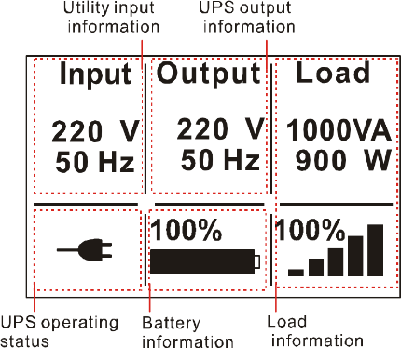

IF ANY OTHER STATUS APPEARS, OR FOR FURTHER GUIDANCE ON WHAT TO DO PLEASE SEE THE TROUBLESHOOTING SECTION ON PAGE 28 OR CONTACT A CertaUPS REPRESENTIVE

OPERATION STATUS | CAUSE | DESCRIPTION
Standby mode  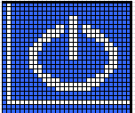 | The UPS is Off | UPS is in stand by mode without any output
Online mode | The UPS is operating normally | The UPS is powered and protecting the equipment
Battery mode  (1 beep every 4 seconds) | Mains failure has occurred, the UPS is in Battery mode | The UPS is powering the equipment from battery power. Prepare equipment for imminent shutdown
End of backup time  (1 beep every 1 second) | The UPS is in Battery mode and the battery is nearing depletion | This warning is approximate, and the actual time to shutdown may vary depending on the configuration and load.
High-Efficiency mode  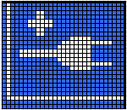  (10ms transfer time in HE) | The UPS is operating in High-Efficiency mode | Once mains power is lost or out of tolerance, the UPS will transfer to Line/Battery mode and the load is supplied from battery power.
Bypass mode  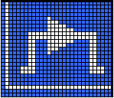 | An overload/fault has occurred, or the UPS has been instructed to enter Bypass mode. | Equipment is powered but not protected by the UPS.
Converter mode  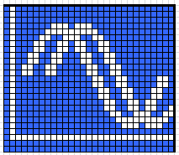 | The UPS is operating in converter mode, where the UPS will provide fixed output frequency (50Hz or 60Hz) | In converter mode, Once the mains power is lost or out of tolerance. The UPS will transfer to battery mode and the load is supplied continuously
Warning  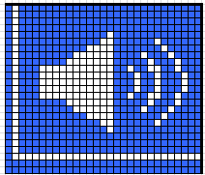 | Warnings are present, this will not necessarily affect operation. | The UPS continues working, but the problem should be identified and resolved immediately, or it could prevent normal operation of the UPS
Fault  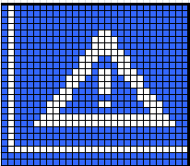 | A fault has been detected | The UPS will immediately cut off the output/transfer to bypass and present an alarm
Overload  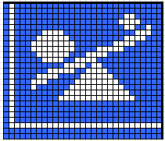 | The load exceeds the capacity of the UPS | The excess load should be removed to meet the UPS output rating
Battery test  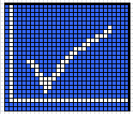 | UPS is executing a battery test | The UPS is performing a Battery test. This is a normal scheduled self-maintenance test and is part of normal operation
Battery fail  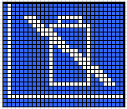 | The UPS has detected a fault or a battery is disconnected | The battery failure symbol is shown and UPS will alarm. The fault should be investigated by a qualified UPS engineer

DISPLAY FUNCTIONS

The UPS is controlled using basic button functions via the LCD panel, basic operation functions include:

- Use the two middle buttons ( and ) to scroll through the menu structure.

- Press the Enter ( ) button to select an option.

- Press the button to cancel or return to the UPS status summary screen.

- When starting the UPS, the display is in the default UPS status summary screen.

MAIN MENU | SUBMENU | DISPLAY INFORMATION OR MENU FUNCTION
UPS status | N/A | [status summary screen] / [Alarm] / [Battery charging/Volt/level/remain time] / [mode/ Para Num. /Running time]
Measurements | N/A | [Load] W VA/ [Output/Current] A % /  [Output/Voltage] V Hz/ [Input/Voltage] V Hz /  [Battery] V % / [DC bus] V V /  [temperature] °C /[Battery remaining time] Min
Control | Buzzer mute | The buzzer will stop sounding
 | Single battery test | Starts a manual battery test for single UPS
 | Parallel UPS battery test | Starts a manual parallel battery test
 | Load segments | Switches on/off to the two load outputs at the rear
 | Clear EPO status | Resets the unit after an EPO event
 | Reset fault status | Clears active fault
 | Single UPS turn off | Turns off one UPS in a parallel UPS system
 | Clear event log | Clears events
 | Restore factory settings | Returns all settings to original values
Settings | N/A | Sets parameters
Event log | N/A | Event list
Identification | N/A | [Product type/model] / [Part/Serial number] / [UPS firmware]

USER SETTINGS

The following table displays the options that can be changed by the user:

SUBMENU | AVAILABLE SETTINGS | DEFAULT SETTINGS
Password | Key the password | USER
Language | [English] [Chinese] | English
User password | [Disabled] [Enabled] | [Disabled]
Audible alarm | [Enabled] [Disabled] | [Enabled]
Output voltage | [208V] [220V] [230V] [240V]  Can be changed in Standby mode and bypass mode | [230V]
Output frequency | [Autosensing] [50Hz] [60Hz] | [Autosensing]
Power strategy | [Normal] [High efficiency] [Converter] | [Normal]
Auto bypass | [Enabled] [Disabled] | [Enabled]
Auto-restart | [Enabled] [Disabled]  Authorize the product to restart automatically when the mains supply is restored after a complete discharge | [Enabled]
Dry in | [Disabled] [SON] [SOFF] [Maintain bypass] | [Disabled]
Dry out | [Loaded power] [On battery mode] [Battery low] [Battery disconnected] [Bypass output] [UPS normal] | [Loaded power]
Start on battery | [Enabled] [Disabled] | [Enabled]
External Battery Modules | [0~20] | [1]
External Battery AH Setting | [0~300] | [120]
Battery remaining time | [Disabled] [Enabled] | [Enabled]
Charger current | [0~4]  0~4A for -B  [0~12]  0~12A for -C | [1.4A] for 6K, [2A] for 10K  [4A] for 6KS/10KS
Site wiring fault alarm | [Disabled] [Enabled] | [Disabled]
LCD contrast | [-5 ~ +5] | [+0]
Ambient temperature warning | [Enabled] [Disabled] | [Enabled]
Automatic overload restart | [Enabled] [Disabled] | [Enabled]
Short curcit clearance | [Enabled] [Disabled] | [Disabled]
Automatic battery test period | [0-21 Days] | [7 Days]

LCD MENU SYSTEM

The LCD display can be used to access detailed information about the current UPS status.
BY DEFAULT, THE LCD WILL DISPLAY THE UPS STATUS SUMMARY SCREEN.

To cycle through the available UPS status summary screen information;

- Press or for less than 1 second and this will cycle information types: Alarms > Battery > System status > Summary screen

MAIN MENU

To access the main menu, start from the UPS status summary screen

- Press for more than 1 second and the display will enter the main menu.

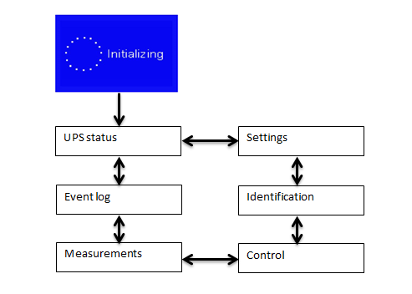
The main menu includes six areas:

- UPS status
- Event log
- Measurement
- Control
- Identification
- Settings

The following section outlines the working schematic for each of the above menu items.
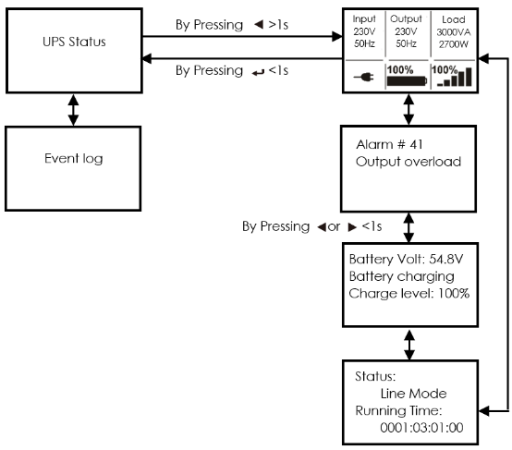

UPS STATUS

- From the main menu pressing on the “UPS status” option, the display will enter the UPS status menu.

- By pressing for 1 second at any time, will return the display to the last main menu.

- Pressing at any time will return the display to the Ups summary screen.

The content of the UPS status menu provides additional information to the status summary screen.

MEASUREMENTS MENU

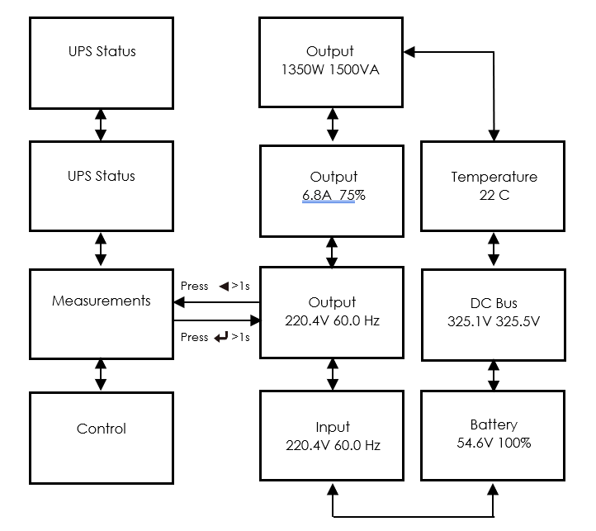
- Press on the “Measurement” option, this will enter the measurement menu.

A lot of detailed information is available within this menu, including output voltage and frequency, output current, load capacity, input voltage and frequency, etc.

- By pressing or the displayed measurement can be changed.

- Pressing for 1 second at any time, will return the display to the last main menu.

- Pressing at any time will return the display to the UPS summary screen.

EVENT LOG

- By pressing on “Event log” the display will enter the event menu.

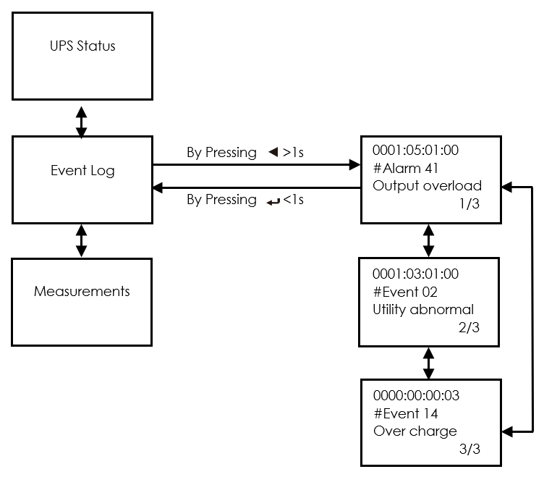
All previous events, alarms and faults will have been recorded here. This includes the description, event code, and the precise time when the event occurred.

The maximum number of recorded events is 50. When the event log is full the oldest event will be overwritten.

CONTROL MENU
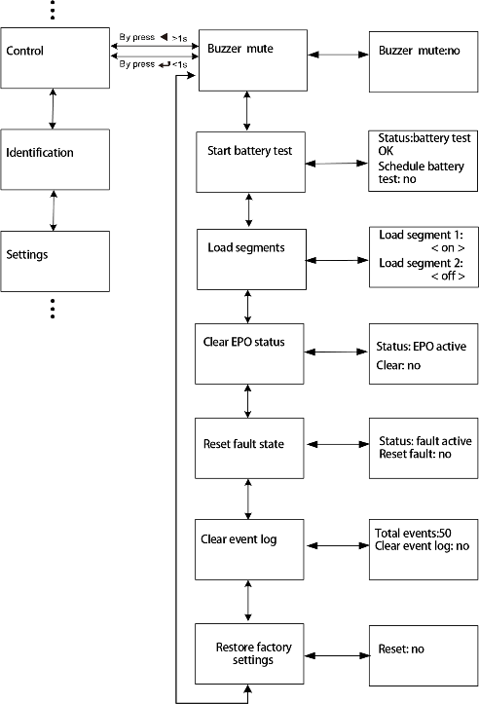
- By pressing on the menu of “Control”, the display enters the control menu.

  - Battery test: this commands the UPS to carry out a battery self-test.

  - Reset fault status: when a fault occurs, the UPS will stay in fault mode and alarm until acknowledged. To clear the alarm, enter the “Reset Fault status” menu to clear the error. The UPS will stop alarming and return to bypass mode. The cause of the fault should be established and cleared prior to the ups being returned to normal operation

  - Restore factory settings: all the settings will be returned to their factory defaults. This can only be done while in bypass mode.

IDENTIFICATION MENU
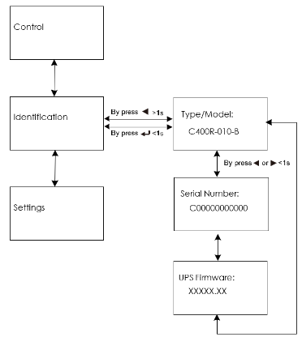
- The identification information includes UPS serial number, firmware version and model.

TO REGISTER A FAULT PLEASE VISIT WWW.CERTAUPS.COM/SUPPORT/FAULT-REPORTING/

SETTINGS MENU

Please contact your local CertaUPS partner for further information before configuring the UPS.
MISCONFIGURATION COULD RESULT IN FAILURE OF THE EQUIPMENT AND PERSONAL INJURY.

Most settings in this menu require the UPS to be in bypass to take effect.

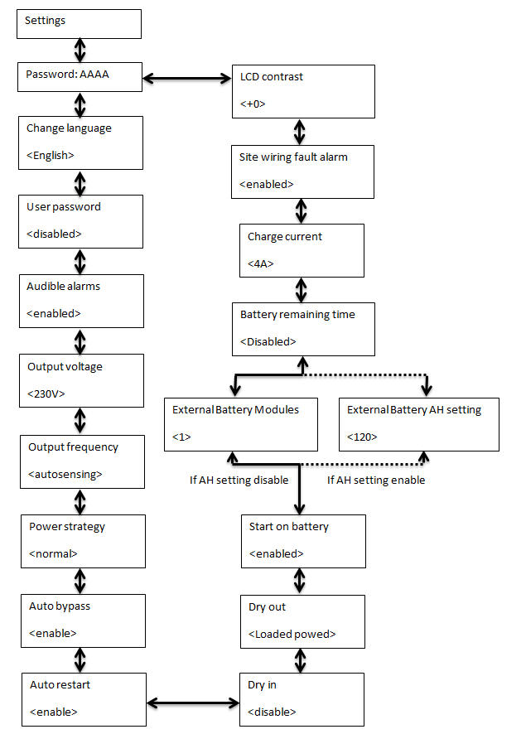

COMMUNICATION PORTS

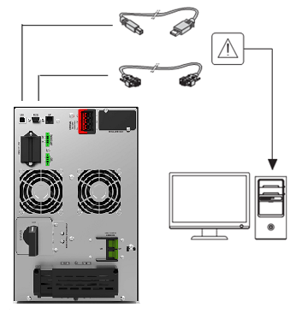
RS232/USB

The RS232 and USB communication ports cannot be used simultaneously.

- Connect the communication cable to the serial or USB port on the computer.

- Connect the other end of the communication cable to the RS232 or USB communication port on the UPS.

Both RS232 and USB connections allow for 2 way communication between the device connected and the UPS. This can be used for both issuing configuration commands, communicating with the UPS and issuing shutdown commands. When connected via USB to a PC the UPS will present itself as a HID compliant ACPI device allowing for zero configuration shutdown initiated by the UPS in the event of a power failure.

EPO CONNECTION

The EPO (Emergency Power Off) connection allows the UPS to be powered off by changing the state of either a normally open or normally closed circuit. The default state of the connection can be configured via the LCD display settings.

- Normally open - Normally the EPO circuit is open on the rear panel. Once the connector is closed with a wire, the UPS will stop output until EPO status is reset.

- Normally closed - Normally EPO connector is closed with a wire on the rear panel. Once the connector is open, the UPS will stop output until the EPO status is disabled.

DRY IN/DRY OUT CONTACTS

Dry in allows maintenance bypass to be remotely switched on and off. When the contact changes the maintenance bypass is switched on or off depending on its current state.

Dry out could indicate the status of UPS.
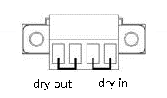

The Dry out port is normally closed, if the Dry out port is open it indicates an event has occurred such as:

Output overload
On battery mode
Battery low
Battery disconnected
Bypass enabled

INTERFACE CARDS (OPTIONAL)

The Network Management Card allows the UPS to communicate with monitoring devices by utilising network connectivity. The C400R series has one available expansion bay for the following connectivity cards:

- NMC/SNMP Card – this interface card provides SNMP and HTTP capabilities as well as monitoring through a Web browser interface using RJ45 10/100Mbps over TCP/IP.

- AS400 card - for RS485 communication protocol. Please contact your CertaUPS partner for details.

SOFTWARE

The C400R series is compatible with WinPower which is an open-source, online UPS monitoring and management software tool.

Key features:

- Power flow display for monitoring UPS status
- Scheduled system shutdown/restart
- Warning notification via E-mail / SMS / Windows system log*
- Scheduled UPS test
- Password security protection
- Remote monitor/control via LAN
- Safety to shutdown multi-system
- Selectable User Interface (Background)
- UPS parameter setting
- SNMP Central monitoring up to 1000 units
- Record logs for analysis
- Multi-language support: English, Italian, Turkish, Spanish, French, Portuguese, Polish, Thai, Germanic, Russian and Japanese.
*Requires a GSM modem (not supplied)

WinPower installation:

STEP ONE | Go to: https://www.certaups.com/downloads/ download winpower
STEP TWO | Choose the operating system you need and follow the instruction described on the website to download the software.
STEP THREE | When downloading all the required files from the internet, enter the product key:  511C1-01220-0100-478DF2A

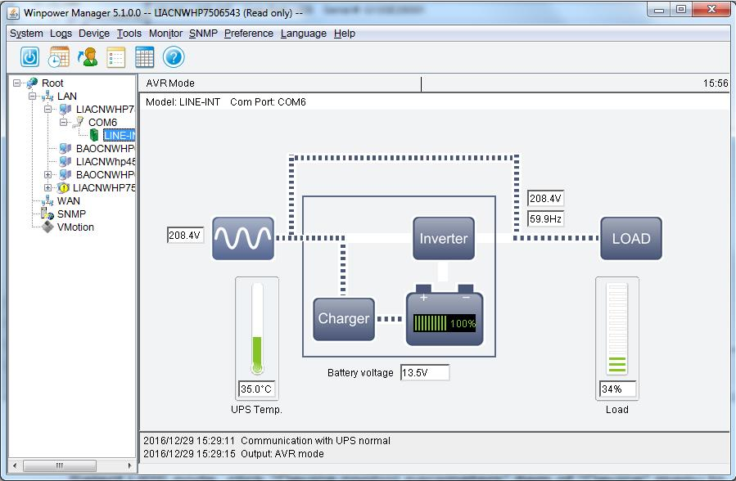
WHEN THE INSTALLATION IS COMPLETE, WinPOWER WILL APPEAR AS A GREEN PLUG ICON LOCATED IN THE SYSTEM TRAY, NEAR THE CLOCK.

FOR FURTHER GUIDANCE ON UPS MONITORING, PLEASE CONTACT YOUR CertaUPS PROVIDER OR VISIT WWW.CERTAUPS.COM

UPS MAINTENACE
ADOPTING A PREVENTATIVE MAINTENANCE SCHEDULE IS CRITICAL TO ACHIEVING OPTIMUM UPS PERFORMANCE

UPS CARE

For the best preventive maintenance:

Keep the area around the equipment clean
Keep the equipment free from dust
Ensure the equipment is positioned in a well-ventilated area
For maximum battery life keep the equipment at an ambient temperature of 20-25°C (77°F max)
Carry out regular environmental and battery checks

The batteries are rated for a 3-5 year service life. The service life varies depending on the frequency of usage and ambient temperature. Batteries used beyond expected service life will often have severely reduced runtimes. Replace batteries at least every 4 years to keep units running at peak efficiency and prevent failure.

TRANSPORTING THE UPS

THE INTERNAL UPS BATTERIES MUST BE DISCONNECTED BEFORE TRANSPORT

The following procedure should be performed or supervised by personnel knowledgeable about batteries and the required precautions. Keep unauthorised personnel away from batteries. If the UPS requires any type of transportation, the batteries must be disconnected (but not removed) before the unit is transported:

Verify that the UPS is off and disconnected from mains power
Place the UPS on a flat stable surface with the front of the cabinet facing you
Remove the UPS front cover
Disconnect the internal battery connectors
Replace the UPS front cover

To avoid damage and to prevent DOA’s always use a reputable courier for all equipment transportation.

STORING THE UPS
UPS BATTERIES MUST BE RECHARGED EVERY SIX MONTHS. ALWAYS CHECK THE BATTERY RECHARGE DATE ON THE SHIPPING CARTON BEFORE USE.

Where UPS equipment is stored for a long period of time, the batteries must be recharged every six months. The optimal storage vdc for VLRA batteries, depending on the environment is between 20-40%. This can be achieved by connecting the UPS to mains power.

DO NOT store the equipment in a warm, damp, dusty environment
DO NOT use the equipment if the batteries have not been recharged/if the recharge date exceeds six months
DO NOT Expose the UPS to direct sunlight or source of heat

DO Store the equipment in a cool, dry, clean environment
DO Ensure the batteries are recharged every six months for a minimum of 48 hours
DO Ensure EBMs are recharged every six months for a minimum of 3 hours

BATTERY REPLACEMENT
DO NOT DISCONNECT THE BATTERIES WHILE THE UPS IS IN BATTERY MODE
CONSIDER ALL WARNINGS, CAUTIONS, AND NOTES BEFORE REPLACING BATTERIES

ELECTRIC ENERGY HAZARD. DO NOT ATTEMPT TO ALTER ANY BATTERY WIRING OR CONNECTORS. ATTEMPTING TO ALTER WIRING CAN CAUSE INJURY

DO NOT allow unauthorised personnel near the batteries. Servicing should be performed by qualified, knowledgeable personnel only
DO NOT dispose of batteries in a fire. Batteries may explode when exposed to flame
DO NOT open or modify the battery or batteries in any way. Released electrolyte is harmful to the skin and eyes and maybe extremely toxic
DO NOT attempt to alter any battery wiring or connectors. Attempting to alter wiring can cause injury

DO ensure personnel servicing the batteries are all knowledgeable on the required precautions for battery servicing
DO replace the batteries with the same type and number of batteries or battery packs
DO dispose of the batteries responsibly. Please refer to local regulations and disposal requirements
DO determine if the battery is inadvertently grounded. If inadvertently grounded, remove source to ground. Contact with any part of a grounded battery can result in electrical shock. The likelihood of shock can be reduced if grounds are removed during installation and maintenance (applicable to equipment and remote battery supplies not having a grounded supply circuit).
DO disconnect charging source prior to connecting or disconnecting battery terminals

Batteries can present a risk of electrical shock or burn from high short circuit current. Observe the following precautions:

Remove watches, rings, or other metal objects
Use tools with insulated handles
Do not lay tools or metal parts on top of batteries
Wear rubber gloves and boots

REPLACING THE EBM
THE EBM IS HEAVY AND REQUIRES A MINIMUM OF 2 PEOPLE TO LIFT INTO RACKING.

For the C400R rotation module: If a PDU is connected to the UPS, turn the MBS to bypass and switch off the input, it is then safe to replace the EBM(s). If a PDU is not connected to the UPS, turn off the UPS and then replace the EBM.

To replace the EBM(s):

- Unplug the EBM power cable and battery detection cable from the UPS. If additional EBM(s) are installed, unplug the EBM power cable from each EBM
- Replace the EBM(s)

A SMALL AMOUNT OF ARCING MAY OCCUR WHEN CONNECTING AN EBM TO THE UPS.
THIS IS NORMAL AND WILL NOT CAUSE SHOCK. INSERT THE EBM CABLE INTO THE UPS BATTERY CONNECTOR QUICKLY AND FIRMLY

- Plug the EBM cable(s) into the battery connector(s)
- Verify that the EBM connections are secure and that adequate bend radius and strain relief exist for each cable
- Connect the EBM cable to the UPS

To test new batteries:

- Charge the batteries for 48 hours.
- Press on the menu of “Control”.
- Select Control
- Select Single battery test

The UPS starts a battery test if:

  - The batteries are fully charged
  - The UPS is in Normal mode with no active alarms
  - Bypass voltage is acceptable

During the battery test, the UPS transfers to Battery mode and discharges the batteries for 10 seconds. The front panel displays 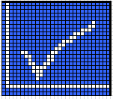 and the percentage of the test completed.

RECYCLING A UPS
CONTACT YOUR LOCAL RECYCLING OR HAZARDOUS WASTE CENTRE FOR INFORMATION ON PROPER DISPOSAL OF THE USED EQUIPMENT.

DO NOT dispose of the battery or batteries in a fire. Batteries may explode. Proper disposal of batteries is required. Refer to your regulations for disposal requirements.

DO NOT open or modify the battery or batteries. Released electrolyte is toxic and harmful to the skin and eyes.

DO NOT discard the UPS or the UPS batteries in the general waste. This product contains sealed lead-acid batteries and must be disposed of responsibly. For more information contact your local recycling centre.

DO NOT discard of waste electrical or electronic equipment (WEEE) in the trash. For proper disposal contact your local recycling centre.

TROUBLESHOOTING

The C400R series is designed for durable, automatic operation. It also provides alerts whenever potential operating problems occur.
ALARMS SHOWN ON THE CONTROL PANEL DO NOT MEAN THAT THE OUTPUT POWER IS AFFECTED. INSTEAD THEY ARE PREVENTIVE ALARMS INTENDED TO ALERT THE USER

- Events are silent status information that are recorded into the Event log. Example = "AC freq in range".
- Alarms are recorded into the Event log and displayed on the LCD status screen with the logo blinking. Some alarms may be announced by a beep every 1 second. Example = "Battery low".
- Faults are announced by a continuous beep and red LED recorded into the Event log. Example = Out. Short circuit.

To check the Event log:

- By pressing on the menu of “Event log”.
- Scroll through the listed events or faults.
- The following table describes typical conditions.

ALARMS & FAULTS
TO REGISTER A FAULT PLEASE VISIT WWW.CERTAUPS.COM/SUPPORT/FAULT-REPORTING/

Use the following troubleshooting chart to determine the UPS alarm condition.

ALARM CODE | EVENT | CAUSE | ACTION
N/A | FAILURE TO RESPOND OR ILLUMINATE | No mains input detected by the UPS | Check building wiring, fusing and input wiring
N/A | RUNTIME LOWER THAN EXPECTED | Batteries not fully charged / batteries require replacement | Charge the batteries for at least  5 - 8 hours and then check capacity. If the problem persists, consult your CertaUPS representative
84 | INTERNAL FAN SPEED ABNORMAL | Low RPM or fan failure | Check the fan is running and free from obstruction
16 | BATTERIES OVERCHARGED | Batteries are overvoltage | The C400R will automatically discharge to the correct value and maintain the battery voltage
12 | LOW BATTERY | Battery voltage is low | An alarm will sound every second, the battery is almost empty
15 | CHARGER FAIL | A critical failure of the charging module has occurred | Consult your CertaUPS representative
86 | HIGH INTERNAL TEMPERATURE | The internal temperature of the UPS is too high | Check ventilation of the UPS, also consider the ambient temperature
82 | HIGH AMBIENT TEMPERATURE | The ambient temperature is too high | Check environment and ventilation
11 | BATTERY OPEN | Batteries not connected correctly | Check the EBM is correctly connected, confirm the Battery breaker is on
13 | SERVICE FAILURE | Battery condition is preventing proper operation | Consult you CertaUPS representative
41/42/43 | UPS OVERLOADED | The UPS is overloaded | Remove noncritical load, check for attached device failure
71 | EPO ENABLED | The EPO state has changed condition NO/NC | Confirm reason for activation and reset EPO status
21 | BUS HIGH | Fault preventing proper operation | Consult you CertaUPS representative
22 | BUS LOW | Fault preventing proper operation | Consult you CertaUPS representative
23 | BUUNBALANCED | Fault preventing proper operation | Consult you CertaUPS representative
25 | SOFT START FAILURE | Fault preventing proper operation | Consult you CertaUPS representative
32/33/34 | INVERTER FAILURE | Fault preventing proper operation | Consult you CertaUPS representative
81 | OVER TEMP | UPS is Over temperature preventing proper operation | Check ventilation of the UPS, also consider the ambient temperature
87 | NTC OPEN | Internal UPS fault | Consult you CertaUPS representative
31 | INVERTER SHORT | Output short Circuit | Remove all loads. Turn off the UPS. Check output wiring and load for short circuit before turning on
24 | BUS SHORT | Internal UPS fault | Consult you CertaUPS representative

Check the alarm condition and perform the applicable action to resolve the condition.

If an alarm status changes the alarm will need to be silenced again.

TECHNICAL DATA

BLOCK DIAGRAM

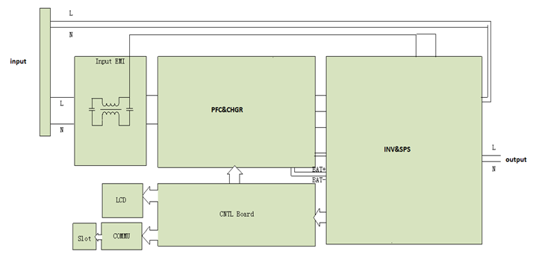

ELECTRICAL SPECIFICATION

INPUT
Model No. | C400R-010-B |  |  | C400R-010-C |  |  | C400R-020-B |  | C400R-020-C | C400R-030-C |  | C400R-030-C
Phase | Single
Frequency | 50/60Hz +/- 10%
AC Voltage (V) | 220/230/ 240/250V |  | 220/230/ 240/250V |  |  | 220/230/ 240/250V |  |  | 220/230/ 240/250V | 220/230/ 240/250V |  | 220/230/ 240/250V
Current(A) | 230V / 7.5A |  |  |  |  | 230V / 13.5A |  |  |  | 230V / 16A
OUTPUT
Model No. | C400R-010-B/C |  |  |  | C400R-020-B/C |  |  |  |  |  | C400R-030-B/C
Power rating* | 1000VA/900W |  |  |  | 2000VA/1800W |  |  |  |  |  | 3000VA/2700W
Voltage | 208VAC/220VAC/230VAC/240VAC
Frequency | 50/60Hz
Waveform | Sinusoidal
BATTERIES
Model No. | C400R-060-B | C400R-060-C (EBM) |  |  | C400R-100-B |  |  | C400R-100-C  (EBM) |  |  | C400RR-060-C (EBM | C400RR-100-C  (EBM)
Voltage | 36V | 32V |  |  | 48V |  |  | 48V |  |  | 72V | 72V
Capacity | 7Ah x 3 | 7Ah x 6 (EBM) |  |  | 9 ah x 4 |  |  | 9Ah x 8 (EBM) |  |  | 9 ah x 6 | 9Ah x 12 (EBM)

OPERATING ENVIRONMENT

Ambient Temperature | 0 °Cto 40 ° C (Full load no de-rating)  40 °C to50 °C output power derated to 50% load, Charger current derated 50%
Operating humidity | < 95% no condensing
Altitude | < 3000m
 | 3000m (Above 3000m altitude10% derating per 1000m)
Storage temperature | -25°C~55°C (-13 to 130°F)
Audible noise | < 50 dBA at 1 meter typical for 6kVA models  < 55 dBA at 1 meter typical for 10kVA models
*Above 3000m altitude10% derating per 1000m.

RUNTIMES
*
MODEL | EBM CODE | EBM QTY | RUNTIME @ 100% | RUNTIME @ 75% | RUNTIME @ 50% | RUNTIME @ 25%
C400R-010-B | NA | 0 | 3 Mins | 6 Mins | 10 Mins | 23 Mins
C400R-010-C | NA | 0 | 0 Mins | 0 Mins | 0 Mins | 0 Mins
C400R-010-C | C400R-BB1 | 1 | 19 Mins | 28 Mins | 47 Mins | 102 Mins
C400R-010-C | C400R-BB1 | 2 | 48 Mins | 72 Mins | 114 Mins | 231 Mins
C400R-010-C | C400R-BB1 | 3 | 83 Mins | 117 Mins | 185 Mins | 300+
C400R-010-C | C400R-BB1 | 4 | 117 Mins | 164 Mins | 259 Mins | 300+
C400R-010-C | C400R-BB1 | 5 | 153 Mins | 215 Mins | 300+ | 300+
C400R-010-C | C400R-BB1 | 6 | 190 Mins | 265 Mins | 300+ | 300+
C400R-020-B | NA | 0 | 3 Mins | 6 Mins | 11 Mins | 25 Mins
C400R-020-C | NA | 0 | 0 Mins | 0 Mins | 0 Mins | 0 Mins
C400R-020-C | C400R-BB2 | 1 | 11 Mins | 17 Mins | 28 Mins | 65 Mins
C400R-020-C | C400R-BB2 | 2 | 29 Mins | 43 Mins | 72 Mins | 152 Mins
C400R-020-C | C400R-BB2 | 3 | 49 Mins | 74 Mins | 117 Mins | 245 Mins
C400R-020-C | C400R-BB2 | 4 | 73 Mins | 105 Mins | 165 Mins | 300+
C400R-020-C | C400R-BB2 | 5 | 96 Mins | 136 Mins | 216 Mins | 300+
C400R-020-C | C400R-BB2 | 6 | 118 Mins | 168 Mins | 266 Mins | 300+
C400R-030-B | NA | 0 | 3 Mins | 6 Mins | 12 Mins | 27 Mins
C400R-030-C | NA | 0 | 0 Mins | 0 Mins | 0 Mins | 0 Mins
C400R-030-C | C400R-BB3 | 1 | 12 Mins | 18 Mins | 30 Mins | 69 Mins
C400R-030-C | C400R-BB3 | 2 | 31 Mins | 45 Mins | 77 Mins | 158 Mins
C400R-030-C | C400R-BB3 | 3 | 52 Mins | 78 Mins | 124 Mins | 255 Mins
C400R-030-C | C400R-BB3 | 4 | 78 Mins | 110 Mins | 174 Mins | 300+
C400R-030-C | C400R-BB3 | 5 | 102 Mins | 143 Mins | 228 Mins | 300+
C400R-030-C | C400R-BB3 | 6 | 125 Mins | 176 Mins | 282 Mins | 300+
*Calculated to 20°C

DIMENSIONS AND WEIGHTS

Model No. | Dimensions W×H×D (mm) | Net Weight (kg)
C400R-010-B | 438X86.5x436 | 16.2
C400R-010-C | 438X86.5x436 | 8.4
C400R-020-B | 438X86.5x436 | 19.7
C400R-020-C | 438X86.5x436 | 9.3
C400R-030-B | 438X86.5x605 | 28.6
C400R-030-C | 438X86.5x605 | 13.2
C400R-BB1 | 438X86.5x436 | 6.8
C400R-BB2 | 438X86.5x436 | 6.7
C400R-BB3 | 438X86.5x605 | 9.3

A FULL GLOSSARY OF TERMS CAN BE FOUND AT:
WWW.CERTAUPS.COM/SUPPORT/UPS-GLOSSARY/
FOR FURTHER INFORMATION OR ASSISTANCE, PLEASE CONTACT YOUR CertaUPS REPRESENTATIVE OR VISIT:
WWW.CERTAUPS.COM

